**English Survey**



## Investigation and Research on the Phenomenon of the 'Hot Pursuit of Civil Service Exams'

**Compiled by:**

|  |  |
| --- | --- |
| **Group Leader:** | **SY2303526 杨和鹭** |
| **Members:** | **ZY2314111 李世伟** |
|  | **SY2306310 顾晨宇** |
|  |  |

Dec 22, 2023

|  |  |  |
| --- | --- | --- |
| **Table Of Contents** | | |
| **Chapter** | **Topic** | **Page** |
|  | Table of Contents | 1 |
|  | Abstract | 2 |
| Chapter 1 | Introduction | 4 |
| Chapter 2 | Analysis of Survey Results | 5 |
|  | 2.1 Competitive Pressure | 5 |
|  | 2.2 Economic Environment | 7 |
|  | 2.3 Salary and Social Welfare Security | 9 |
|  | 2.4 Social Concepts | 11 |
| Chapter 3 | Conclusion and Discussion | 11 |
| References | The Articles Referenced in the Paper | 13 |
| Appendix A | Questionnaire（Chinese） | 15 |
| Appendix B | Questionnaire（English） | 19 |

**Abstract**

Since ancient times, Chinese individuals have harbored a deep-seated inclination toward pursuing positions in public service and civil service examinations. Influenced by Confucian ideals, scholars in ancient China held a dual perspective on entering government service. On one hand, there was a pragmatic pursuit of wealth, fame, and family honor; on the other, a more idealistic aspiration to contribute to the well-being of the people, uphold righteousness, continue the teachings of past sages, and strive for eternal peace.

In recent years, the number of individuals participating in civil service and public administration examinations has been steadily increasing. In 2024, the nationwide registration for the National Civil Service Examination exceeded 2.91 million, representing an increase of nearly 1.5 million compared to 2017. The enthusiasm for public service careers is visibly and consistently on the rise. The allure of pursuing civil service or administrative positions lies in the promise of stable employment opportunities, presenting a significant chance for young people. Concurrently, certain high-paying industries, such as the internet and finance sectors, have faced challenges like salary reductions, industry cyclicality, and layoffs. In comparison, the stability offered by public service or administrative roles is increasingly attractive.

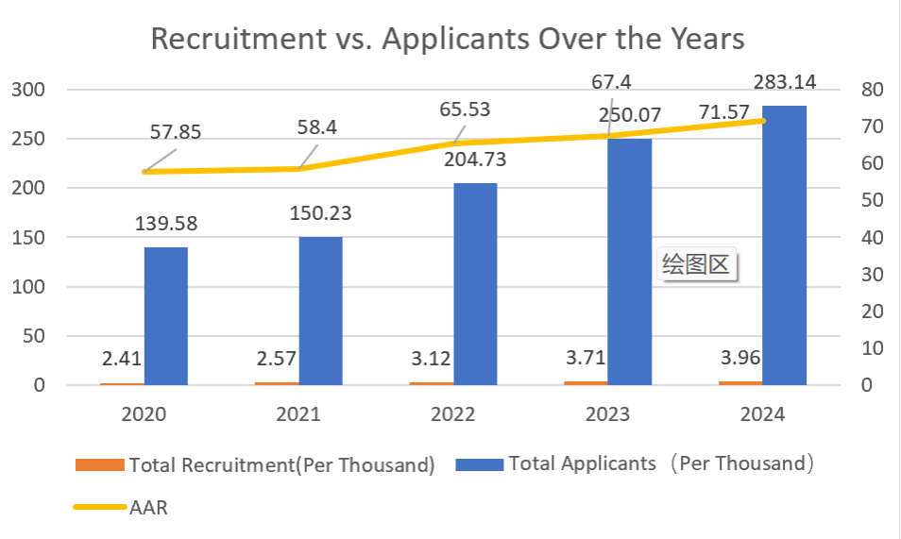

Figure 1The Changes in Recruitment Numbers, Application Numbers, and Applicant-to-Admission Ratio (AAR) Over the Past Few Years

To gauge the perspectives of individuals in our vicinity, a survey was conducted among graduate and undergraduate students in higher education institutions. The survey incorporated an analysis of various academic disciplines to derive comprehensive insights. The findings indicate that, overall, 80% of respondents express a willingness to consider careers in civil service or administrative positions. However, attitudes toward pursuing such roles vary among different disciplines, with students confident in securing satisfactory employment post-graduation expressing less pronounced interest in civil service or administrative careers.

This report provides a glimpse into the evolving dynamics of career choices among Chinese students and underscores the enduring appeal of public service and civil service examinations in the contemporary context. The intersection of tradition, changing economic landscapes, and individual aspirations illuminates the multifaceted nature of this societal phenomenon.

**Keywords:** Civil service exam enthusiasm, questionnaire survey, university students.

## Chapter 1: Introduction

The term " Civil service exam enthusiasm" refers to the process of obtaining a position as a civil servant or within the institutional structure of a public institution through a series of selection procedures, including written exams and interviews. The government recruits civil servants to select individuals with a certain level of knowledge, professional competence, and a service-oriented mindset to meet the needs of government institutions and social services.

Civil servants typically enjoy relatively stable job positions and favorable benefits, including high salaries, medical insurance, and retirement benefits. Furthermore, civil service positions are often viewed as a way to contribute to society, as individuals in these roles participate in and influence policy formulation and social management.

In 2024, the nationwide registration for the National Civil Service Examination exceeded 2.91 million, setting a new record for the number of participants. In terms of position registration, the average competition ratio for registered positions exceeded 66:1, indicating intense competition.

It is noteworthy that the phenomenon of "uneven popularity" is also a feature of the National Civil Service Examination registration. In this registration cycle, while some positions became increasingly popular, there were still 136 positions with no applicants. These less sought-after positions often have more restrictive conditions or are located in western, remote, and challenging areas. For instance, a position as a police officer in the grassroots unit of the Golmud Railway Public Security Bureau of the Qinghai-Tibet Railway, with 8 vacancies, had zero applicants.

As the main force in taking civil service exams, individuals born in the 1990s and 2000s, amidst the rapidly changing employment landscape, find choosing relatively stable civil service positions as a platform for realizing their societal and life values to be appropriate. Some experts argue that initially, young people may choose to take civil service exams simply to lead an envisioned "lying flat" lifestyle. However, investigations by "Xinmin Weekly" have shown that contemporary young people, represented by those born in the 2000s and 1995s, have diverse aspirations beyond "stability" when considering civil service exams. They express confusion but are willing to seek change. Moreover, a portion of young individuals sees civil service exams as a means of self-realization in the new era.

As university students, how do our peers perceive the current enthusiasm for civil service exams? Will they participate in the civil service examination? Through a survey questionnaire consisting of 16 questions and the collection of 20 sets of data, we aimed to understand students' opinions on civil service exams and the choices between civil service exams and employment. Choosing civil service exams is a personal decision, and its significance varies among different students. When better job opportunities arise, individuals still prefer working outside the system. As Sun Yat-sen wrote when inscribing the Huangpu Military Academy, "Ascend to higher positions and accumulate wealth, move to other places; Fear not death, avoid entering this gate." For civil service positions, serving the people is their true mission.

## Chapter 2: Analysis of Survey Results

The decision to pursue civil service examinations is driven by various factors, primarily including competitive pressure, the domestic economic environment, salary and benefits, and societal perspectives. The following section will analyze the survey results based on these key aspects.

### 2.1 Competitive Pressure

According to the survey report, 43.75% of the students indicate that they will choose to participate in the civil service or career establishment exams in the future. However, 72.73% of the students have people around them who are participating in such exams. Additionally, more than half of the students encourage their friends or classmates around them to take the civil service or career establishment exams. 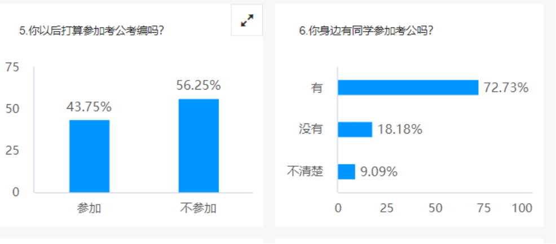

Figure 2 The Proportion of Civil Service Exam Participants

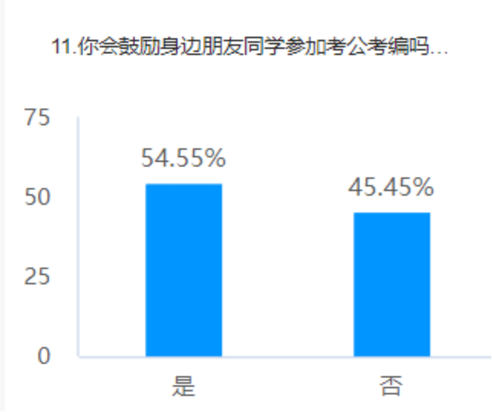

Figure 3 The Proportion of Support for Friends Taking Civil Service Exams in One's Surroundings

The reason for the popularity of civil service exams lies in the significant competition pressure. Currently, influenced by the continuous changes in the international situation and factors of social instability, many enterprises have been severely impacted. The economic situation is not as favorable as before, with numerous companies not only implementing layoffs but even canceling recruitment and plans for new positions. They are cutting costs and conserving funds, resulting in a narrow job market. This has made the career path selection more challenging for graduates nationwide, and opportunities have become increasingly scarce. Many graduates' chosen majors and the knowledge and skills acquired in school do not align with the positions that companies are recruiting for, leading to a phenomenon where graduates are out of sync with societal demands, and the competition pressure is intensifying.

While salary and compensation are undoubtedly crucial, individuals also care about the magnitude of work pressure and whether the working environment is satisfactory. Considering these factors, civil service positions indeed become an enticing choice.

However, this gives rise to another dilemma – the limited number of civil service positions contrasts with the enormous number of applicants, resulting in intense competition. In 2024, nearly 3 million people participated in the national civil service exam, with an average competition ratio of 66:1, slightly higher than the 60:1 ratio in 2023. Among the popular positions, the top-ranking position was in the "National Bureau of Statistics Ningxia Survey Detachment Business Office Level 1 Director and below" role. The competition ratio for this position soared to 3572:1, with only one vacancy available. Figure 3 illustrates that 86.36% of individuals perceive significant competition pressure in civil service and career establishment exams.

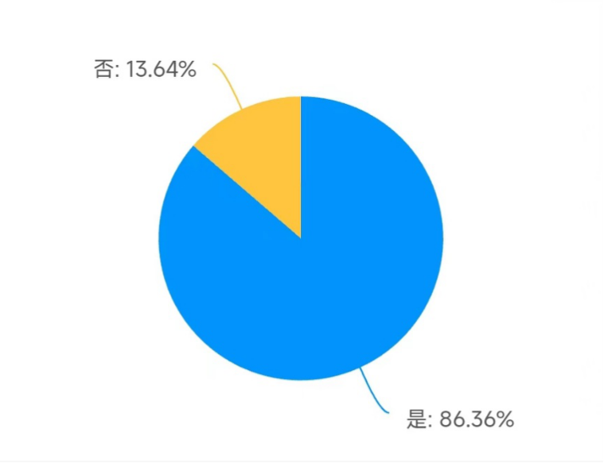

Figure 4 People's Perceptions of the Competitive Pressure in Civil Service Exams

### 2.2 Economic Environment

One significant factor behind the fervor for civil service examinations is the current economic environment. Amid economic fluctuations and increased uncertainty in employment, an escalating number of individuals are opting to pursue civil service positions as a stable employment choice. This phenomenon is, in part, rooted in the perceived stability associated with civil service jobs. Civil service positions are generally considered a relatively stable career option. Compared to the private sector and other industries, government positions are often less susceptible to market fluctuations and economic turbulence. This relative stability in the work environment has become a preferred choice for many individuals seeking to evade the uncertainties prevalent in the job market. Figure 4 illustrates that among various reasons, stable income and having time for family are two primary factors for individuals choosing to take civil service exams.

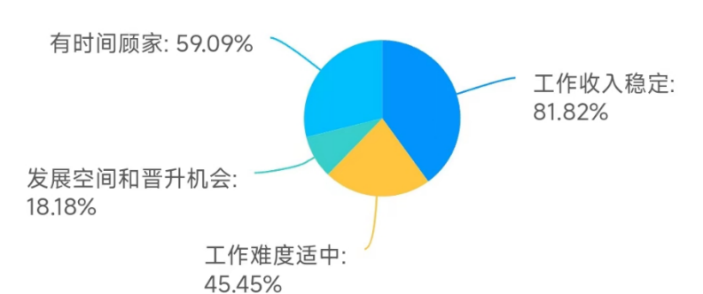

Figure 5 The Percentage of Reasons for Choosing to Take Civil Service Exams

Some analyses suggest that the phenomenon of the intense popularity of the National Civil Service Examination lacks sustainability. It not only fails to maximize the talent effect but is also detrimental to the comprehensive and coordinated development of the economy and society. Therefore, there is a need to encourage and develop the real economy, enhance the capacity of non-governmental entities to absorb employment, and facilitate the gradual cooling down of the fervor for the National Civil Service Examination. Figure 5 shows that the number of people who believe that the enthusiasm for civil service exams needs to "cool down" is only 22.73%.

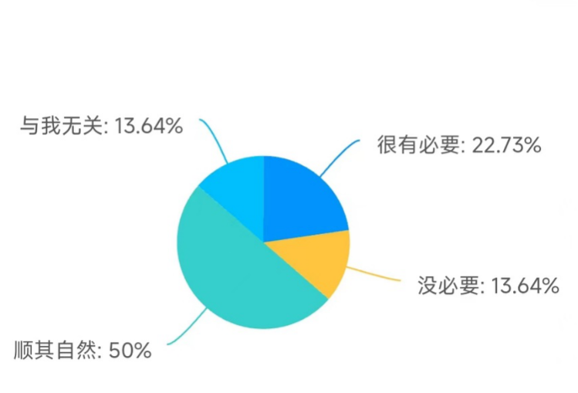

Figure 6 Whether There is a Need for the 'Cooling Down' of the Enthusiasm for Civil Service Exams

### 2.3 Salary and Social Welfare Security

Considering the job aspects, being a civil servant remains a quite desirable occupation. The income of civil servants is now transparent, and workers can find relevant information online. While considering salary alone, civil servants may not be the highest earners in every industry, but they still hold relatively high positions, especially in grassroots townships and county towns in the eastern and western regions. The opportunities for other professions to surpass civil servants in terms of salary are quite limited.

In comparison to private enterprises, the salary of civil servants is more stable, not heavily affected by market fluctuations and economic downturns. Additionally, the income in this profession is well assured, with employees not having to worry about the timing of their monthly pay. There is also a lack of career crises, as the individual professional value of civil servants does not significantly depreciate with age, which is an advantage not shared by many private sector professions.Civil servants typically enjoy abundant welfare benefits, including but not limited to medical benefits, retirement pension systems, and housing and provident funds.

Figure 6 indicates that when there are better employment opportunities, people would choose to give up civil service positions. On the other hand, Figure 7 demonstrates that when there are better job opportunities, people generally wouldn't prioritize civil service positions immediately, indicating that individuals place greater emphasis on salary and compensation. However, 40.91% of individuals would weigh their options, highlighting the strong appeal of civil service positions and further affirming the fervor for civil service exams.

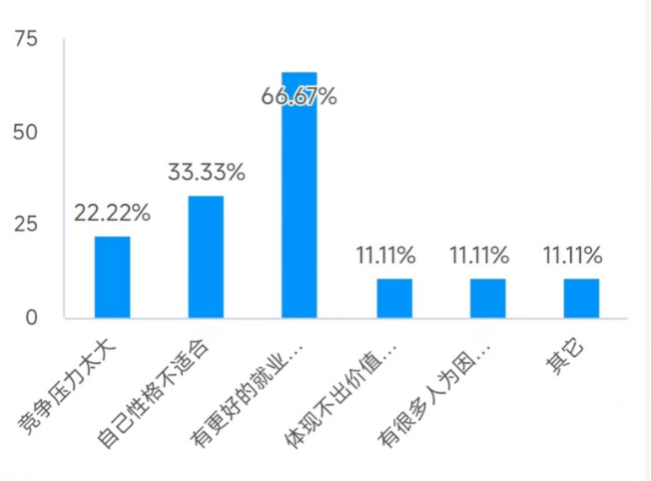

Figure 7 The Reasons People Choose Not to Take Civil Service Exams

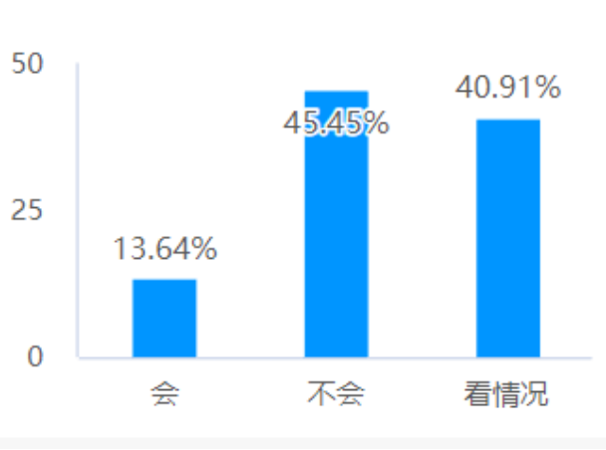

Figure 8 People's Choices When There Are Better Job Opportunities

### 2.4 Social Concepts

In recent years, as societal culture and values have shifted towards a return to tradition, the profession of civil servants, which has been highly esteemed since ancient times, has naturally become even more sought after.

Civil servants are typically seen as representatives of social service, with their responsibilities encompassing providing services to the public, solving issues, and promoting social development. There is a widespread belief that by becoming a civil servant, one can make a positive contribution to society and foster social fairness and justice. Furthermore, being a civil servant implies stable income and an elevation in social status.

Figure 8 shows that the reasons why classmates choose to take civil service exams are primarily personal or influenced by those around them, indicating a strong endorsement of civil service exams. People generally believe that succeeding in civil service exams will provide a basic guarantee for future life and lead to a relatively happy life.

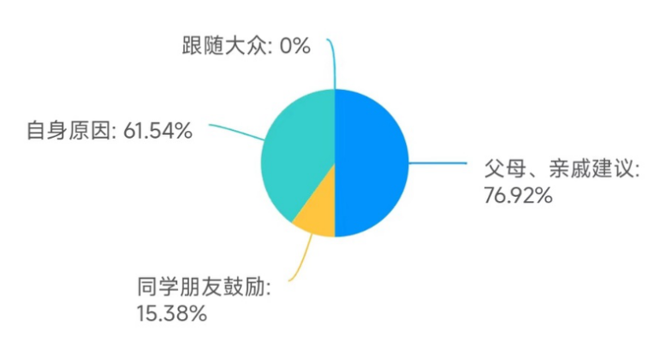

Figure 9 The Source of Ideas for Taking Civil Service Exams

## Chapter 3: Conclusions and Discussion

**Conclusion**

Based on the comprehensive analysis of the survey data, the following conclusions can be drawn:

(1) Competition pressure is the primary reason for choosing civil service exams. The survey indicates that over 40% of students express their intention to participate in civil service exams. Moreover, over 70% of students state that they have friends with experience in civil service exams. This suggests that the current employment environment exerts significant competition pressure on college graduates, making civil service positions a popular choice. Over 80% of respondents believe that the competition pressure for civil service exams is substantial.

(2) Economic conditions drive the enthusiasm for civil service exams. With the current economic downturn, many companies face challenges, leading to a reduction in job opportunities. In such circumstances, the relative stability of civil service positions attracts an increasing number of job seekers. Job stability and the ability to balance work and family life are identified as the main reasons for choosing civil service exams.

(3) Salary and benefits are among the attractions of civil service exams. The relatively higher salary and benefits offered by civil service positions are crucial factors influencing people's choice to pursue civil service exams. While some may abandon civil service exams when presented with better job opportunities, 40% indicate a willingness to weigh the options, highlighting the attractiveness of civil service positions in terms of salary and benefits.

(4) Influence of social attitudes. In recent years, there has been an increased societal recognition of the civil service profession. Civil servants are seen as representatives of social service, contributing positively to social fairness and justice. The primary reasons for students choosing civil service exams are personal considerations and the influence of those around them, reflecting the impact of social attitudes on individual career choices.

**Discussion**

The popularity of civil service exams reflects the pressure and uncertainty in the current job market. Many believe that only by passing the civil service exams can they secure relatively stable employment and income, while other industries are seen as having higher employment risks. However, this also exposes the insufficient support for other industries in society, as well as the limitations on talent mobility and diversity. Therefore, we need to consider how to better balance the relationship between civil service and other industries, and how to better support and develop various sectors, thereby raising the overall level of societal development.

This phenomenon may also lead to a decline in the quality of the civil service workforce, as some individuals may only be taking the civil service exams for the sake of obtaining stable employment and welfare benefits, rather than having a genuine passion and interest in civil service work. Workplace competition is becoming increasingly fierce, not only evident in civil service exams but also across various industries and positions. With the progress of society, the demands for people's qualifications and abilities are increasing. It is not only necessary to possess professional knowledge but also good communication skills, teamwork, innovation, and more. Therefore, continuous learning and improving one's overall qualities are essential to stand out in the intense competition of the workplace. For those aiming for success in their careers, diligence, and continuous progress are indispensable.

## References

[1]方彬楠,冉黎黎. “考公”热的低门槛与高热度[N]. 北京商报,2023-08-22(002).

[2]陈冰.考公考编热的背后[J].新民周刊,2023(26):6-7.

[3]王仲昀.当越来越多年轻人决定“考公考编”[J].新民周刊,2023(26):8-13.

[4]. 呵护青年人闯荡的勇气[N]. 经济观察报,2023-12-04(001).

[5]金朝力,冉黎黎. 国考“热”与考研“冷”下的就业观[N]. 北京商报,2023-11-27(002).

**Questionnaire on the willingness to**

**take the civil service examination**

1. What is your gender? *

|  |
| --- |
| ○Male |
| ○Female |

2. You are currently *

|  |
| --- |
| ○Undergraduate |
| ○Graduate |
| ○Social personnel |

3. Have you ever understood the basic requirements and timing for recruiting civil servants or positions with established positions? *

|  |
| --- |
| ○Clear understanding |
| ○General understanding |
| ○Do not understand |

4. Have you ever taken the civil service or civil service recruitment exam? *

|  |
| --- |
| ○Yes |
| ○No |

5. Do you plan to take the civil service exam in the future? *

|  |
| --- |
| ○Yes |
| ○No |

Dependent on the second option of question 4

6. Do you have any classmates around you who are taking the civil service exam? *

|  |
| --- |
| ○Yes |
| ○No |
| ○I don’t know |

7. What advantages do you think the staffing position has for other jobs? *

|  |
| --- |
| □Stable work income |
| □Moderate work difficulty |
| □Development space and promotion opportunities |
| □Have time to take care of family |

8. If there were better opportunities for other jobs, would you still choose to take the civil service exam? *

|  |
| --- |
| ○Yes |
| ○No |
| ○It depends |

9. Will you participate in institutional training courses if you take the civil service exam? *

|  |
| --- |
| ○Yes |
| ○No |

10. The idea or decision to take the civil service examination or civil service examination comes from *

|  |
| --- |
| □Suggestions from parents and relatives |
| □Encouragement from classmates and friends |
| □Self reasons |
| □Follow the public |

Dependent on the first option of question 4 and the first option of question 5

11. Would you encourage your friends and classmates to participate in the civil service exam? *

|  |
| --- |
| ○Yes |
| ○No |

12. How do you feel about the difficulty of the civil servant or establishment position exam? *

|  |
| --- |
| ○Very difficult |
| ○Difficult |
| ○General |
| ○Easy |

Dependent on the first option of question 4

13. Do you think the competitiveness of taking the civil service examination and civil service examination is increasing? *

|  |
| --- |
| ○Yes |
| ○No |

14. If you decide not to take the civil service civil service examination, is that because? *

|  |
| --- |
| □Too much competitive pressure |
| □Not suitable for my own personality |
| □There is a better employment direction and no need for it |
| □Unable to reflect value and social status |
| □Many human factors feel that they are at a disadvantage |
| □Other |

Dependent on the second option of question 5

15. If you are not admitted at once, will you still take the exam again? *

|  |
| --- |
| ○Yes |
| ○No |

Dependent on the first option of question 5

16. Do you think the trend of "taking the civil service exam and becoming a civil servant" needs to be cooled down? *

|  |
| --- |
| ○Very necessary |
| ○No need |
| ○Let nature take its course |
| ○Not related to me  **考公意愿调查问卷**  1. 你的性别是 [单选题] *   |  | | --- | | ○男 | | ○女 |   2. 你目前是 [单选题] *   |  | | --- | | ○本科在读 | | ○研究生在读 | | ○社会人员 |   3. 你是否了解过公务员或者编制岗招考基本条件和时间? [单选题] *   |  | | --- | | ○清楚了解 | | ○大概了解 | | ○不了解 |   4. 你是否参加过公务员或者编制岗招考？ [单选题] *   |  | | --- | | ○是 | | ○否 |   5. 你以后打算参加考公考编吗？ [单选题] *   |  | | --- | | ○参加 | | ○不参加 |   依赖于第4题第2个选项  6. 你身边有同学参加考公吗？ [单选题] *   |  | | --- | | ○有 | | ○没有 | | ○不清楚 |   7. 你认为编制岗对于其它工作有什么优势？ [多选题] *   |  | | --- | | □工作收入稳定 | | □工作难度适中 | | □发展空间和晋升机会 | | □有时间顾家 |   8. 如果有更好的其他工作的机会，你还会选择考公吗？ [单选题] *   |  | | --- | | ○会 | | ○不会 | | ○看情况 |   9. 如果考公考编你是否会参加机构培训课程？ [单选题] *   |  | | --- | | ○是 | | ○否 |   10. 考公考编的想法或决定来自于 [多选题] *   |  | | --- | | □父母、亲戚建议 | | □同学朋友鼓励 | | □自身原因 | | □跟随大众 |   依赖于第4题第1个选项，第5题第1个选项  11. 你会鼓励身边朋友同学参加考公考编吗？ [单选题] *   |  | | --- | | ○是 | | ○否 |   12. 你对公务员或者编制岗考试难度的感受如何? [单选题] *   |  | | --- | | ○非常难 | | ○较难 | | ○一般 | | ○比较容易 |   依赖于第4题第1个选项  13. 你是否认为考公考编的竞争力越来越大？ [单选题] *   |  | | --- | | ○是 | | ○否 |   14. 如果你决定不考公考编是因为? [多选题] *   |  | | --- | | □竞争压力太大 | | □自己性格不适合 | | □有更好的就业方向，不需要 | | □体现不出价值和社会地位 | | □有很多人为因素觉得自己处于劣势 | | □其它 |   依赖于第5题第2个选项  15. 如果一次没录取，你还会再考吗？ [单选题] *   |  | | --- | | ○会 | | ○不会 |   依赖于第5题第1个选项  16. 你觉得“考公考编热”需要降温吗？ [单选题] *   |  | | --- | | ○很有必要 | | ○没必要 | | ○顺其自然 | | ○与我无关 | |